Coursework 1 Report

Connor Smith

Matric No.40294347

**Personal evaluation**

The challenges I faced more than anything was didn’t have much time due to my personal problems, so was a rushed job. Also the javascript for the cipher script was a challenge to get working.

**Introduction**

The purpose of the website, is first to demonstrate design and coding ability. On the website we must include a cipher, in which ROT1 was used, it’s a very basic cipher, it’s the alphabet rotated forward one, such as A being B, B being C and so on. This was incorporated using javascript.

**Software Design**

The design was very basic when thought of beforehand, was to include, a home page, cipher and design page. I went for a very normal white and black colour scheme, if I had more time I would have included a background of cipher or an image related to ciphers. I thought of just creating a hyperlink menu underneath the main title.

**Implementation**

The index[1] is a very bland, as you can see, it just includes a description and that’s all. The rot1[2] cipher has a encode and decode button meaning you could do the riddle above and the answer is underneath.

**Critical evaluation**

The whole design is boring, I should have added colour or even made the design interesting, it looks like one of the first websites created, so very unoriginal. If I could go back, I would look into how to incorporate images or even made an interacting circle that you can turn to decode messages.

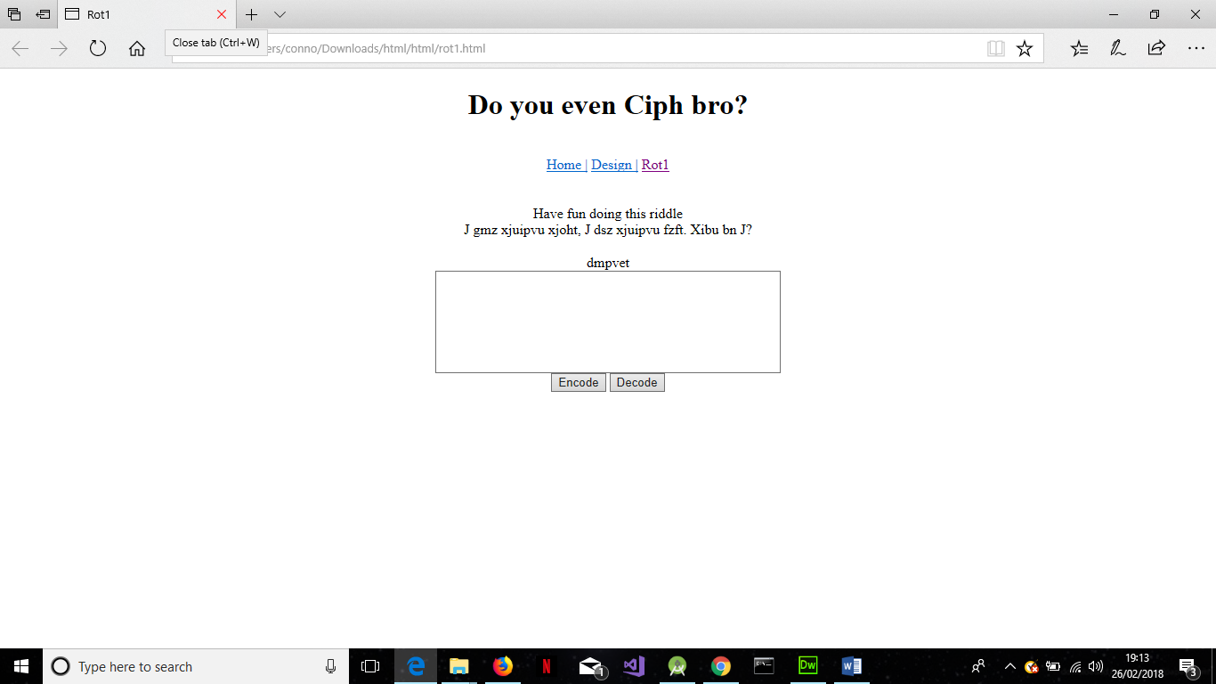[2]